**1. Create a new user account. The account name should be a combination of your first initial and your last name.**

CREATE USER SSOLIMAN

IDENTIFIED BY orcl123456;

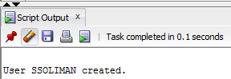

**2. Attempt to log in to Oracle 12c with the newly created account.**

GRANT CREATE SESSION TO SSOLIMAN WITH ADMIN OPTION;

CONNECT SSOLIMAN

orcl123456

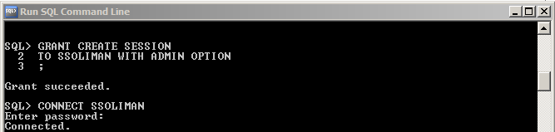

**3. Assign privileges to the new account that allow connecting to the database, creating new tables, and altering an existing table.**

GRANT CREATE SESSION, CREATE TABLE, ALTER ANY TABLE TO SSOLIMAN;

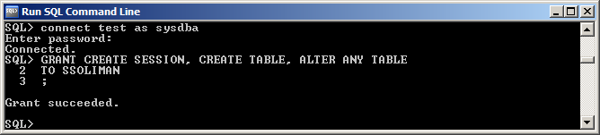

**4. Using an account with the required privileges, create a role named CUSTOMERREP that allows inserting new rows in the ORDERS and ORDERITEMS tables and deleting rows from these tables.**

CREATE ROLE customerrep;

GRANT INSERT, DELETE ON orders

TO customerrep;

GRANT INSERT, DELETE ON orderitems

TO customerrep;

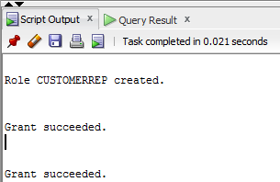

**5. Assign the account created in Assignment 1 the CUSTOMERREP role.**

GRANT customerrep

TO SSOLIMAN;

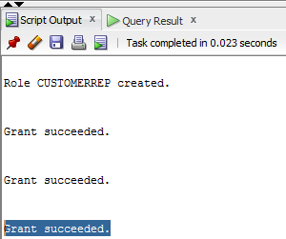

**6. Log in to Oracle 12c with the new account created in Assignment 1. Determine the  
privileges currently available to the account.**

CREATE

CONNECT SSOLIMAN as SYSDBA

orcl123456

SELECT * FROM SESSION_PRIVS;

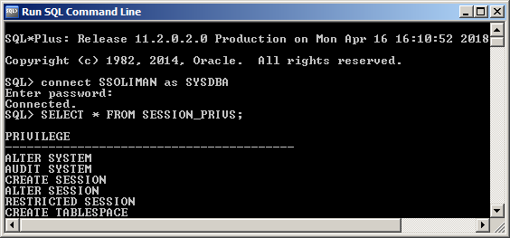

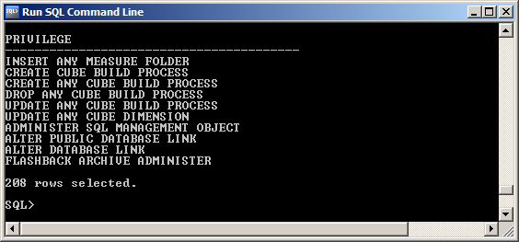

**7. Revoke the privilege to delete rows in the ORDERS and ORDERITEMS tables from the  
CUSTOMERREP role.**

REVOKE Delete

ON Orders

FROM customerrep;

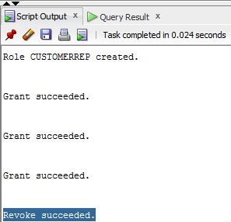

**8. Remove the CUSTOMERREP role from the account created in Assignment 1.**

REVOKE customerrep

FROM SSOLIMAN;

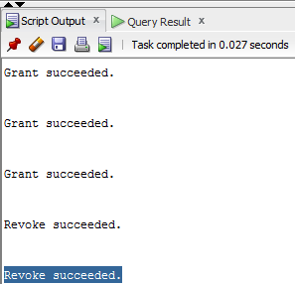

**9. Delete the CUSTOMERREP role from the Oracle 12c database.**

DROP ROLE customerrep;

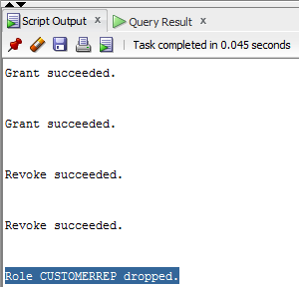

**10. Delete the user account created in Assignment 1.**

DROP USER SSOLIMAN;

